**Ramen Reviews Prototype Documentation**

Jaryl Goh Jun Zhong

**Steps to run the code**:

* Extract entire code file
* Install the relevant packages as stated in requirements.txt
* Run the python file :D

**REST API Endpoint URLs:**

|  |  |
| --- | --- |
| **REST Endpoint URL** | **Purpose** |
| localhost:5000/ | Index/Home page for the web application |
| localhost:5000/reviews | Page where all reviews in the ramen-ratings.db is shown. Options to search, edit and delete reviews are provided at this page as well. |
| localhost:5000/countries | Page where users are able to choose the countries to filter the reviews by. |
| localhost:5000/country/<*Country*> | Page where users will be redirected to upon clicking which country to filter by. |
| localhost:5000/submitform | Page where users are able to click to, to submit new reviews of ramen. |
| localhost:5000/edit_or_delete | Page where users will be redirected upon selecting a review to edit or delete.Will be given different forms depending on choice made (edit or delete). |
| localhost:5000/delete_result | Page where users will be shown that they have deleted the review successfully. Given the hyperlink to be redirected to either the index page or to view, edit or delete more reviews. |
| localhost:5000/edit_result | Page where users will be shown that they have successfully edited the review. Given the hyperlink to be redirected to either the index page or to view, edit or delete more reviews. |

**Index/Home page for the web application:**



* Users are given the options to “View, Search, Edit and Delete Reviews”, “FIlter Reviews”(by Country), and to “Submit a Review!”.

**Reviews page:**

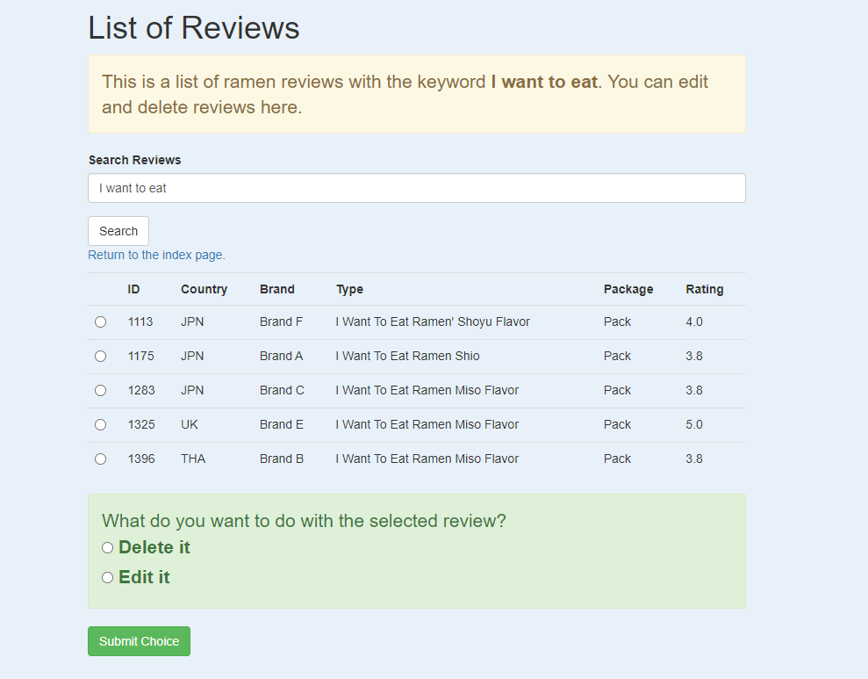

* Users will be given the full list of reviews currently in the database, as well as a search bar for them to search whatever ramen they would like to find.
* The view, search, editing and deleting functions are all in the same page so as to make it easier for users to actually edit and delete reviews that they find odd, instead of having to scroll down trying to find the review they would like to delete.
* Upon trying a ramen listed in the database, they are then able to quickly search and edit the review according to their taste.

**Adding a New Review:**

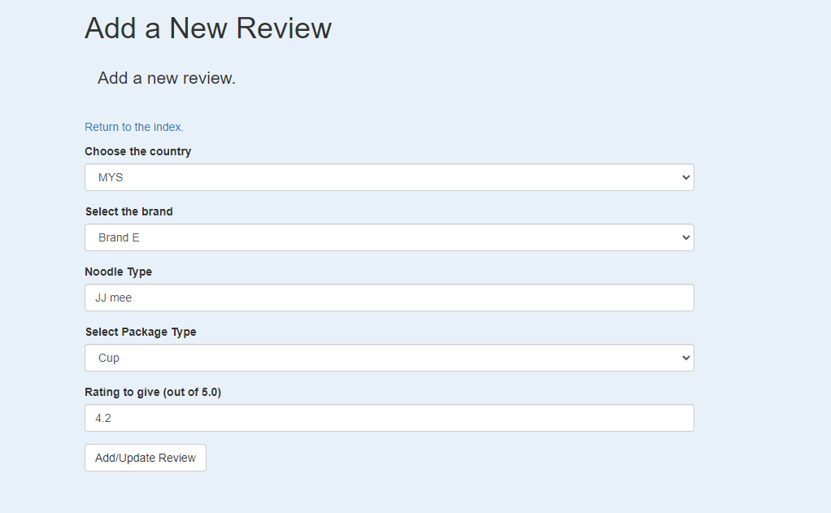

* A form will pop up with the relevant fields for the user to fill up regarding the ramen.

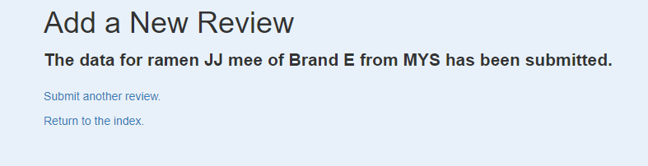

* User will be notified that the review has been submitted
* Hyperlinks provided for user to submit another review or to go back to the index page.

**Editing or Deleting Reviews**:

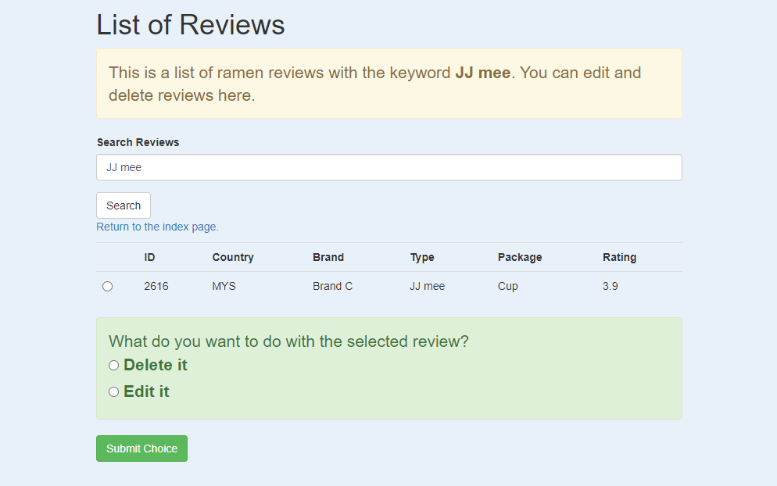

* Users are able to search the relevant review that they would like to edit or delete
* Upon submitting “Edit” or “Delete” they will be redirected to the relevant page.
* They will be asked to confirm again if it is actually what they want to do.

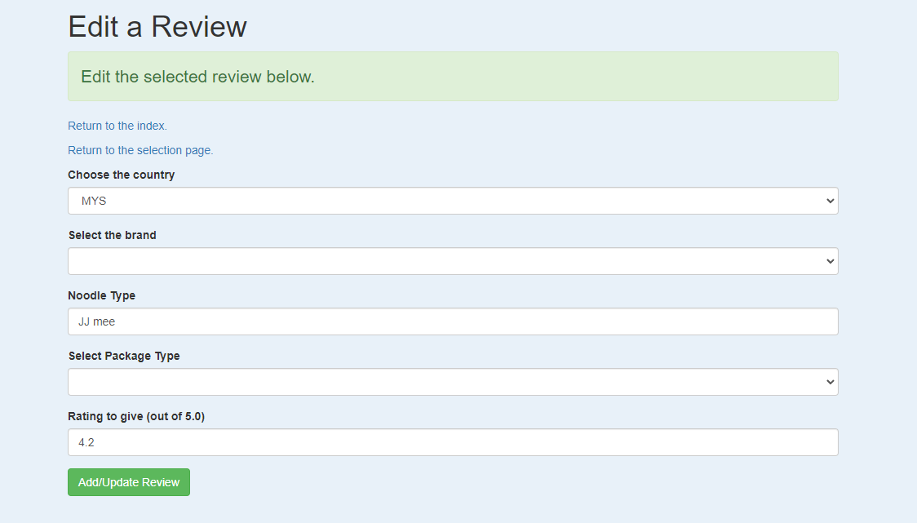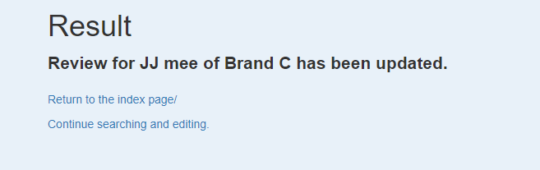

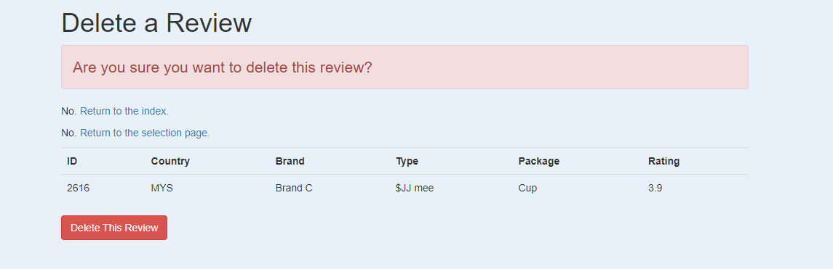

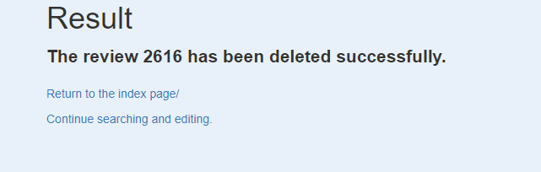

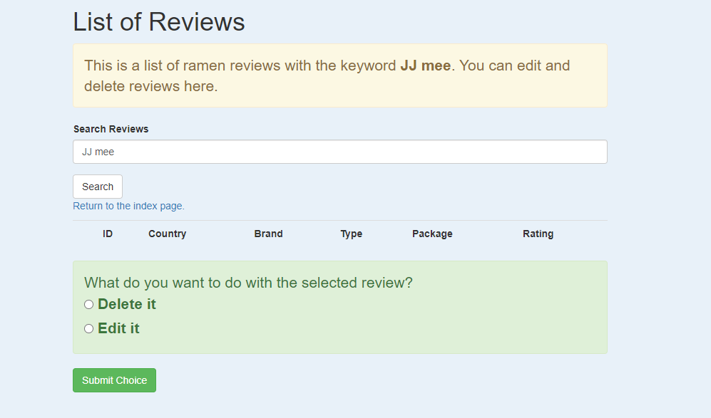

*To confirm that it has already been deleted*